ISTEC TRAINING · TRIPOD BETA INCIDENT ANALYSIS

Driver injured in vehicle roll-over on delivery run (practice copy)
TB-EX-08 · Worked example (Tripod Beta User Guide, Annex 8)
Item | Detail
Date and time | 2026-03-12, 08:00 to 18:30
Location | Remote delivery route, 40 km from the Area Production Centre
Site / business unit | Area Production Centre, Logistics
Loss category | People
Severity | Actual 4 (Major), potential 5 (Catastrophic)
Tripod Beta practitioner | Course facilitator
Report status | Draft

1. Summary
Five trios describe the incident, from the need to transport goods to the permanent disability of the driver. Seven barriers failed. The Tripod causation paths point to weaknesses in journey management, driver fitness and rest control, driver training, seat-belt enforcement and emergency response staffing.
5 trio(s), 7 failed, 0 missing/inadequate and 0 effective barrier(s), 10 underlying cause(s), 17 recommended action(s).

2. Description of the incident
A driver delivering goods to a remote location left the Area Production Centre on schedule at 08:00 and was due back at 12:30. His failure to return was not reported until 15:00. A search along his Journey Management route started at 16:30 without success; he was found off the designated route at 18:30. The vehicle had left the road and rolled over. Local villagers had pulled the driver from the vehicle while he waited for rescue; doctors believe this contributed to a spinal injury that will probably cause permanent disability.

3. Investigation team
Name | Role
Lead investigator (Tripod Beta Practitioner) | Team leader
Logistics superintendent | Process knowledge
HSE adviser | Investigator
Driver representative | Workforce representative

4. Tripod Beta tree
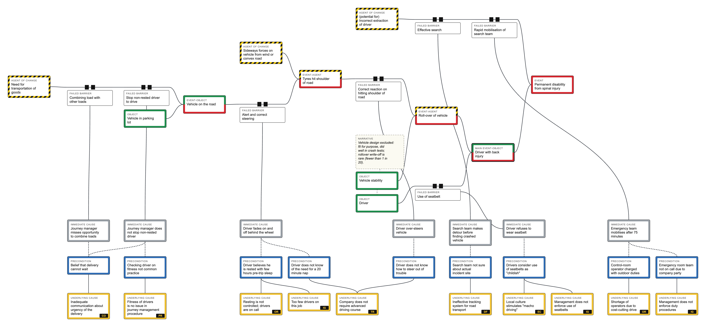
Time runs left to right. Red: Event. Striped: Agent of Change. Green: Object. Paired black blocks: failed barrier. Dashed blocks: missing/inadequate barrier. Solid bar: effective barrier. Grey: Immediate Cause. Blue: Precondition (dotted link). Yellow: Underlying Cause with BRF code.

5. What happened: core diagram
# | Agent of Change | Object | Event | Barriers
1 | Need for transportation of goods | Vehicle in parking lot | Vehicle on the road  Event-Object | 2
2 | Sideways forces on vehicle from wind or convex road | Vehicle on the road | Tyres hit shoulder of road  Event-Agent | 1
3 | Tyres hit shoulder of road | Vehicle stability | Roll-over of vehicle  Event-Agent | 1
4 | Roll-over of vehicle | Driver | Driver with back injury  Event-Object, main event | 1
5 | (potential for) Incorrect extraction of driver | Driver with back injury | Permanent disability from spinal injury  Event | 2

6. How it happened: barriers
Trio | Trajectory | Barrier | Status
1 | Agent side | Combining load with other loads | Failed Barrier
1 | Agent side | Stop non-rested driver to drive | Failed Barrier
2 | Object side | Alert and correct steering | Failed Barrier
3 | Agent side | Correct reaction on hitting shoulder of road | Failed Barrier
4 | Object side | Use of seatbelt | Failed Barrier
5 | Agent side | Effective search | Failed Barrier
5 | Agent side | Rapid mobilisation of search team | Failed Barrier

7. Why it happened: Tripod causation paths

7.1 Failed barrier: Combining load with other loads
Immediate Cause: Journey manager misses opportunity to combine loads (Sub-standard act, Mistake (knowledge-based))
A knowledge-based mistake that has become commonplace.
Precondition: Belief that delivery cannot wait (Organisational)
Underlying Cause: Inadequate communication about urgency of the delivery [CO Communication]

7.2 Failed barrier: Stop non-rested driver to drive
Immediate Cause: Journey manager does not stop non-rested driver (Sub-standard act, Routine violation)
Precondition: Belief that delivery cannot wait (Organisational)
Underlying Cause: Inadequate communication about urgency of the delivery [CO Communication]
Precondition: Checking driver on fitness not common practice (Organisational)
Underlying Cause: Fitness of drivers is no issue in journey management procedure [PR Procedures]

7.3 Failed barrier: Alert and correct steering
Immediate Cause: Driver fades on and off behind the wheel (Sub-standard act, Lapse)
A lapse and possible violation of the "pull off and stop" policy.
Precondition: Driver believes he is rested with few hours pre-trip sleep (Organisational)
Underlying Cause: Resting is not controlled; drivers are on call [OR Organisation]
Underlying Cause: Too few drivers on this job [IG Incompatible Goals]
Precondition: Driver does not know of the need for a 20 minute nap (Organisational)
Underlying Cause: Company does not require advanced driving course [TR Training]

7.4 Failed barrier: Correct reaction on hitting shoulder of road
Immediate Cause: Driver over-steers vehicle (Sub-standard act, Slip)
An instinctive reaction on waking, difficult to resolve by training alone.
Precondition: Driver does not know how to steer out of trouble (Organisational)
Underlying Cause: Company does not require advanced driving course [TR Training]

7.5 Failed barrier: Use of seatbelt
Immediate Cause: Driver refuses to wear seatbelt (Sub-standard act, Routine violation)
Precondition: Drivers consider use of seatbelts as "childish" (Organisational)
Underlying Cause: Local culture stimulates "macho driving" [EC Error-enforcing Conditions]
Underlying Cause: Management does not enforce use of seatbelts [IG Incompatible Goals]

7.6 Failed barrier: Effective search
Immediate Cause: Search team makes detour before finding crashed vehicle (Sub-standard act, Unintentional violation (awareness))
Precondition: Search team not sure about actual incident site (Organisational)
Underlying Cause: Ineffective tracking system for road transport [DF Defences]

7.7 Failed barrier: Rapid mobilisation of search team
Immediate Cause: Emergency team mobilises after 75 minutes (Sub-standard act, Situational violation (no-can-do))
Journey Management Procedure requires a search within 45 minutes of the overdue alert.
Precondition: Control-room operator charged with outdoor duties (Organisational)
Underlying Cause: Shortage of operators due to cost-cutting drive [OR Organisation]
Precondition: Emergency room team not on call due to company party (Organisational)
Underlying Cause: Management does not enforce duty procedures [IG Incompatible Goals]

Notes
• Vehicle design excluded: fit for purpose, did well in crash tests; rollover write-off is rare (fewer than 1 in 20).

8. Basic Risk Factor profile
BRF | Count | Underlying Causes
HW Hardware | 0
DE Design | 0
MM Maintenance Management | 0
PR Procedures | 1 | Fitness of drivers is no issue in journey management procedure
EC Error-enforcing Conditions | 1 | Local culture stimulates "macho driving"
HK Housekeeping | 0
IG Incompatible Goals | 3 | Too few drivers on this job; Management does not enforce use of seatbelts; Management does not enforce duty procedures
CO Communication | 1 | Inadequate communication about urgency of the delivery
OR Organisation | 2 | Resting is not controlled; drivers are on call; Shortage of operators due to cost-cutting drive
TR Training | 1 | Company does not require advanced driving course
DF Defences | 1 | Ineffective tracking system for road transport

9. Recommended actions
# | Addresses | Action | Owner | Due | Priority | Status
1 | Combining load with other loads  (Failed Barrier) | Logistics planners to check delivery urgency with the requester before dispatch and combine non-urgent loads with scheduled truck runs. | Logistics Superintendent | 2026-04-11 | High | Open
2 | Stop non-rested driver to drive  (Failed Barrier) | Add a documented driver fitness and rest check to the journey management pre-departure briefing; Journey Manager to stop any driver who fails it. | Journey Management owner | 2026-04-11 | High | Open
3 | Alert and correct steering  (Failed Barrier) | Brief every driver before departure on fatigue: when drowsy, pull off and take a 20-minute nap. Record the briefing on the Journey Management Plan. | Transport Manager | 2026-03-26 | High | Open
4 | Correct reaction on hitting shoulder of road  (Failed Barrier) | Add recovery from running off the road (slow down, steer back gently) to the practical module of the advanced driving course. | Training Manager | 2026-06-10 | Medium | Open
5 | Effective search  (Failed Barrier) | Require the planned route to be written on the Journey Management Plan and any deviation to be reported to base before it is taken. | Journey Management owner | 2026-04-11 | High | Open
6 | Use of seatbelt  (Failed Barrier) | Make seat-belt use a stated condition of driving company vehicles and check it at gate exits for three months. | Transport Manager | 2026-03-26 | High | Open
7 | Rapid mobilisation of search team  (Failed Barrier) | Rehearse overdue-vehicle search mobilisation against the 45-minute target at random times, quarterly. | Emergency Response Coordinator | 2026-06-10 | Medium | Open
8 | Inadequate communication about urgency of the delivery  (Underlying Cause) | Agree delivery priority definitions with customers and hold a monthly delivery planning meeting. | Logistics Superintendent | 2026-05-11 | Medium | Open
9 | Fitness of drivers is no issue in journey management procedure  (Underlying Cause) | Revise the Journey Management Procedure to include driver fitness, rest and alertness criteria. | HSE Manager | 2026-05-11 | High | Open
10 | Resting is not controlled; drivers are on call  (Underlying Cause) | Introduce duty-hour and minimum-rest rules for drivers and monitor them through the roster. | Transport Manager | 2026-06-10 | High | Open
11 | Too few drivers on this job  (Underlying Cause) | Review driver numbers against trip demand and recruit or reschedule to remove the shortfall. | Operations Manager | 2026-07-10 | Medium | Open
12 | Company does not require advanced driving course  (Underlying Cause) | Require an advanced driving course (alertness, fatigue and vehicle recovery skills) for all drivers. | Training Manager | 2026-09-08 | Medium | Open
13 | Management does not enforce use of seatbelts  (Underlying Cause) | Correct the induction material on seat belts and brief all induction trainers on the company rule. | HSE Manager | 2026-04-11 | High | Open
14 | Local culture stimulates "macho driving"  (Underlying Cause) | Run a line-manager-led driving culture programme with recognition for compliant driving and visible follow-up of risk-taking. | Operations Manager | 2026-07-10 | Medium | Open
15 | Management does not enforce duty procedures  (Underlying Cause) | Audit compliance with emergency duty and on-call procedures monthly and report results to the management team. | Operations Manager | 2026-05-11 | Medium | Open
16 | Shortage of operators due to cost-cutting drive  (Underlying Cause) | Remove outdoor duties from control-room operators while on emergency watch, or add a relief operator. | Operations Manager | 2026-05-11 | Medium | Open
17 | Ineffective tracking system for road transport  (Underlying Cause) | Fit in-vehicle tracking to field vehicles and monitor positions from the control room. | Transport Manager | 2026-09-08 | Medium | Open

10. Lessons learned
• Journey management must cover driver fitness and rest, not only the route.
• Urgency on transport requisitions should be challenged and loads combined.
• Seat-belt use is a company rule regardless of local law and must be enforced from induction onwards.

11. Tree quality check
The tree meets the Tripod Beta tree rules checked by this tool, and every Failed/Missing Barrier and Underlying Cause has a recommended action.

Management review and sign-off
Management should check the appropriateness of the recommendations, especially those on Underlying Causes, and confirm resources for them.
Investigation team leader | Tripod Beta practitioner | Accountable manager
Name, signature, date | Name, signature, date | Name, signature, date

